CS23A34-USER INTERFACE DESIGN

ROLL NO : 240701196 DATE : 03.02.2026
NAME : ISHWARYAA N

🚫 BAD DESIGN (AADHAAR PORTAL) :
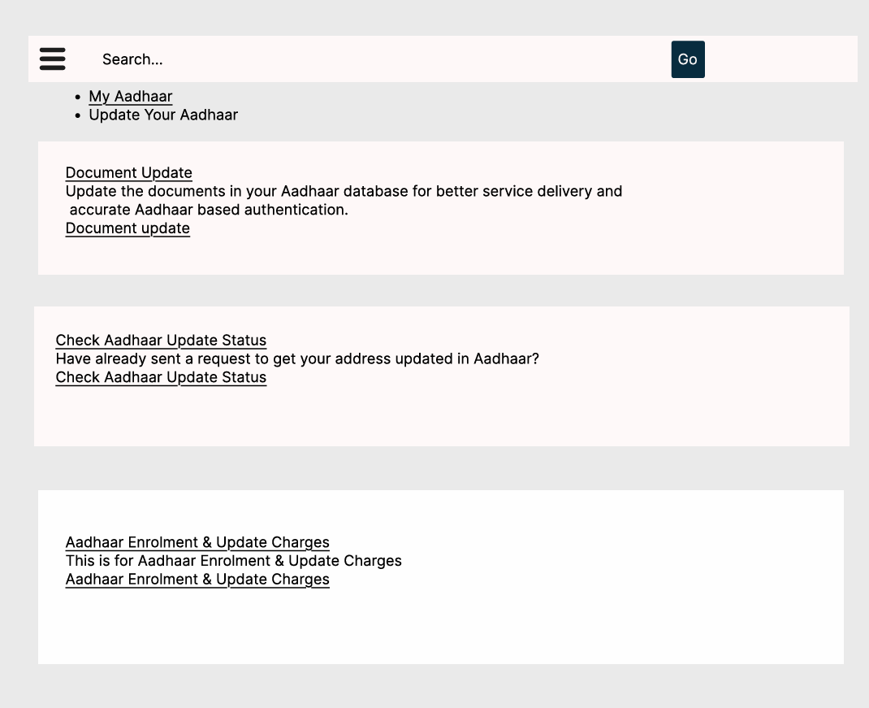

🔹 Design Style
- Plain, text-heavy interface with no visual hierarchy.
- No branding, government insignia, or identity markers.
- Sections look repetitive and cluttered.
- No icons, step indicators, or visual cues to guide users.
- Feels outdated and unprofessional.

🔹 Content
- Redundant repetition of “Update” and “Charges” sections.
- No eligibility information (what can/cannot be updated online).
- No explanation of required documents or security measures.
- Lacks clarity—users must guess the process.
- Content is fragmented, scattered, and not user-friendly.

🔹 Navigation
- Multiple links with similar wording cause confusion.
- No logical flow—users don’t know where to start.
- No single entry point; users must click around blindly.
- Absence of step-by-step guidance.
- Navigation feels like a list dump rather than a structured portal.

🔹 Purpose
- Appears more like a static service list than an interactive portal.
- Focused on displaying options rather than helping users complete tasks.
- Poor alignment with user needs—no clarity on process or requirements.
- Does not inspire trust or confidence in the system.

✅ GOOD DESIGN (AADHAAR PORTAL ) :
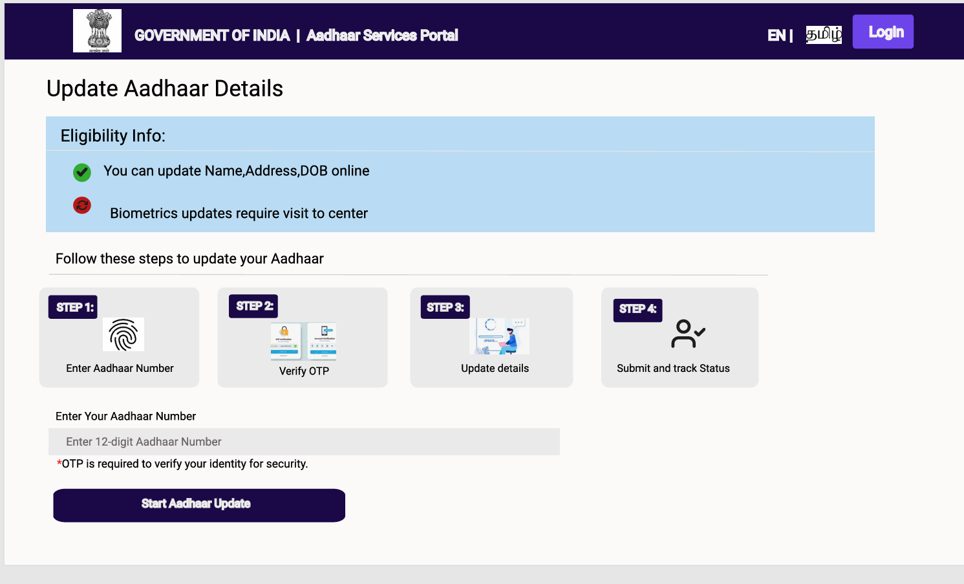
🔹 Design Style
- Clean, structured layout with clear headings and sections.
- Incorporates national identity symbols (सत्यमेव जयते, Government of India).
- Uses checkboxes and step indicators for clarity.
- Professional, modern look with emphasis on usability.
- Balanced use of text and visuals.
🔹 Content
- Provides eligibility info (what can be updated online vs. at center).
- Step-by-step instructions (Enter Aadhaar → Verify OTP → Update → Submit).
- Clear security note about OTP verification.
- Concise, purposeful, and user-focused content.
- Eliminates redundancy and focuses on action.
🔹 Navigation
- Sequential navigation with numbered steps.
- Logical flow from login → verification → update → tracking.
- Single entry point (“Start Aadhaar Update”) reduces confusion.
- Easy to follow even for first-time users.
- Smooth, guided experience.
🔹 Purpose
- Purpose-driven: helps users update Aadhaar quickly and securely.
- Balances information (eligibility, security) with action (update steps).
- Designed to reduce errors and improve service delivery.
- Strong emphasis on user trust and efficiency.
- Aligns with citizen-centric design principles.
Comparison Table:
Aspect | Bad Design (Document 1) | Good Design (Document 2)
Design Style | Text-heavy, cluttered, no branding | Clean, structured, branded with national identity
Content | Redundant, fragmented, no eligibility info | Clear eligibility info, concise, step-by-step instructions
Navigation | Confusing, multiple similar links, no flow | Sequential, guided, single entry point, logical flow
Purpose | Service-list oriented, lacks clarity | Purpose-driven, user-centric, secure, efficient
User Guidance | None, users must guess | Step indicators, OTP verification, clear instructions
Trust Factor | Low—outdated and confusing | High—professional, secure, citizen-focused

Final Conclusion :
It offers:
- Clear navigation and structured workflows.
- Better accessibility and multilingual support.
- Enhanced user experience with security and eligibility info.
- Higher efficiency and reduced cognitive load.

